TCP
Client TCP Code:
from socket import *
import webbrowser
serverName = '127.0.0.1'
serverPort = 11000
fileName = 'HelloWorld.html'
# Create a TCP socket
clientSocket = socket(AF_INET, SOCK_STREAM)
# Connect to the server
clientSocket.connect((serverName, serverPort))
# Send a valid HTTP GET request
request = f"GET /{fileName} HTTP/1.1\r\nHost: {serverName}\r\n\r\n"
clientSocket.send(request.encode())
# Receive the response
response = b""
while True:
data = clientSocket.recv(2048)
if not data:
break
response += data
# Close the connection
clientSocket.close()
# Decode response and extract HTML body
response_str = response.decode()
header, _, body = response_str.partition("\r\n\r\n")
print(f"Response header: {body}")
# Save HTML to a temporary file
output_file = "received_page.html"
with open(output_file, "w", encoding="utf-8") as f:
f.write(body)
print(f"Saved HTML content to {output_file}")
webbrowser.open(output_file)
Server TCP Code
#import socket module
import sys
from socket import *
serverName = '127.0.0.1'
serverPort = 11000
serverSocket = socket(AF_INET, SOCK_STREAM)
serverSocket.bind((serverName, serverPort))
serverSocket.listen(1)
print('The server is ready to receive')
while True:
connectionSocket, clientAddress = serverSocket.accept()
try:
message = connectionSocket.recv(2048).decode()
filename = message.split()[1]
f = open(filename[1:])
outputData = f.readlines()
f.close()
connectionSocket.send("HTTP/1.1 200 OK\r\n\r\n".encode())
for i in range(1, len(outputData)):
connectionSocket.send(outputData[i].encode())
connectionSocket.close()
except IOError:
connectionSocket.send("HTTP/1.1 404 Not Found\r\n\r\n".encode())
connectionSocket.send("<html><body><h1>404 Not Found</h1></body></html>".encode())
connectionSocket.close()

Printouts:
Client
The client receives the Header from the Server and loads the content into a copy version of the HTML file.
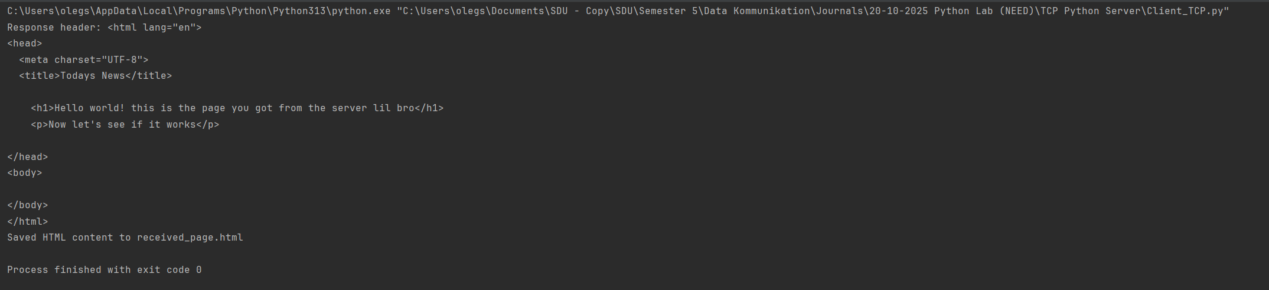
Then the client opens the copied version locally.
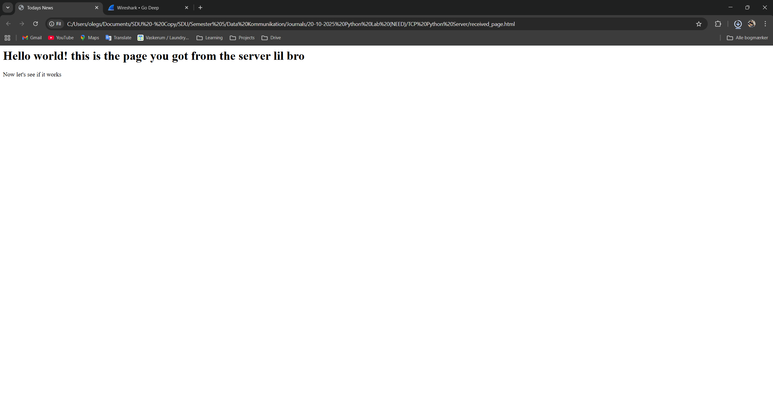
Server
The server is only able to process one client at a time. When the server is running, it will print a message “The server is ready to receive.”

WIRESHARK
To make Wireshark work with it, it is important to start the server using py -3 Server_TCP_HTML.py command. This will make a HTTP call, which Wireshark will be able to track.
In the same way, we should start our client. The client will then receive the content from the server.
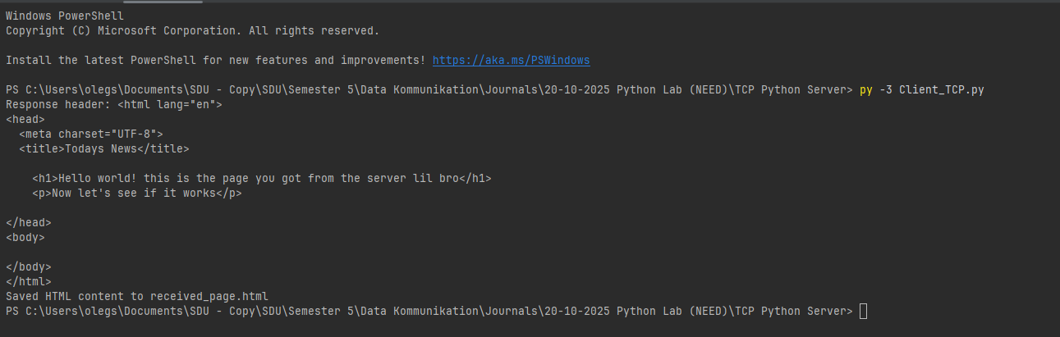
1.
The IP for client is:
The client port is :
2.
Layer | Size | Key Info
IP | 20 bytes | IPv4, proto=6 (TCP), src=127.0.0.1
TCP | 20 bytes | Ports, flags, sequence
HTTP | Data: 223 bytes | “HTTP/1.1 200 OK”
In this capture, the packets are sent over the loopback interface (127.0.0.1), so there is no actual Ethernet header.
IP
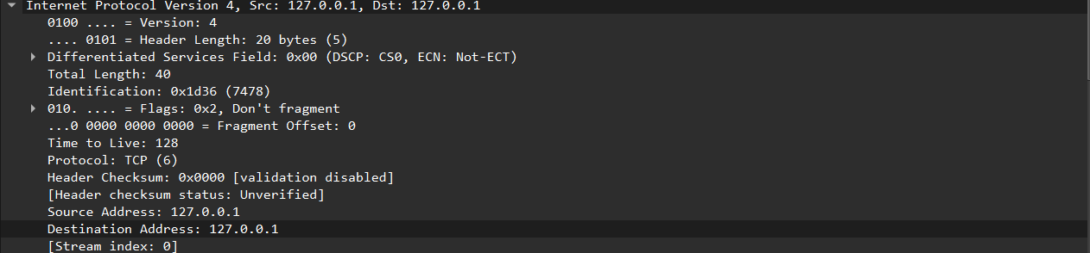
TCP
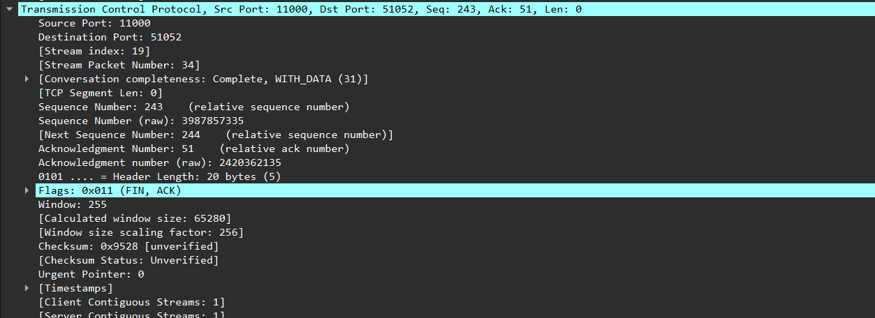
HTTP
